

**SLIIT students’ attitudes and preferences regarding online shopping!**

**Presentation Report**

**Y1S2_2023_MTR_Gr02**

**English for Academic Purposes–IT1080**

**B.Sc. (Hons) in Information Technology**

# Group Details!

|  |  |  |
| --- | --- | --- |
|  | **Student Registration Number** | **Student Name** |
| **1** | IT22253958 | W.P.R. Nethmina |
| **2** | IT22296078 | Sarithmal K.D |
| **3** | IT22226532 | D.V.D Hashan |
| **4** | IT22635952 | Abeywickrama A.S. |
| **5** | IT22244352 | Hewahalpage |
| **6** | IT22371522 | G.H.P Iroshan |

# Submitted on: 01/10/2023

# Terms Of Reference

The purpose of this report is to discuss SLIIT students’ attitudes and preferences regarding online shopping.

A report submitted in fulfilment of the requirement for the module IT1080, Sri Lanka Institute of Information Technology.

# Acknowledgements

We would like to express my sincere gratitude to all those who have contributed to the successful completion of this research project on SLIIT students' attitudes and preferences regarding online shopping. This endeavor would not have been possible without the support, guidance, and cooperation of several individuals and institutions.

First and foremost, we are indebted to our English for Academic purpose lecturer, Mrs. Enoka Hettiarachchi for her invaluable guidance, mentorship, and unwavering support throughout the research process. Her expertise and feedback greatly enriched the quality of this report.

We extend our heartfelt thanks to our university for granting the necessary permissions and providing access to resources that were essential for conducting this research. We are also grateful to the faculty members who offered valuable insights and advice throughout the project.

We would like to express our appreciation to the participants of this study, the university students, whose time and input were indispensable in shaping the findings of this research. Your willingness to share your perspectives and experiences is deeply appreciated.

We also want to acknowledge our family and friends for their encouragement and understanding during the research journey. Your belief in our abilities has been a constant source of motivation.

Lastly, we would like to thank all the authors and researchers whose work in the field of online shopping and consumer behavior served as a foundation for this study.

This research would not have been possible without the collective efforts of these individuals and institutions, and for that, we are truly grateful.

**Table of Contents**

Terms Of Reference 3

Acknowledgements 4

1. Abstract 6

2. Introduction 7

3. Methodology 8

4. Online Shopping with Buyers! 9

4.1. Products at top. 9

4.2. Online Buying Platforms. 11

4.3. Factors affect online Buying. 11

4.4. Methods of Payment. 12

4.5. Challenges as a Buyer. 13

5. Online Shopping with Sellers! 15

5.1. Product of selling 16

5.2. Online Selling Platforms. 16

5.3. Strategies of attracting customers 17

5.4. Challenges as a seller 18

5.5. Handling online selling Business 18

6. Conclusion 20

7. References 21

8. Appendices 22

# Abstract

This report investigates the attitudes and preferences of SlIIT students regarding online shopping, aiming to provide valuable insights into their evolving consumer behavior in the digital age. The study encompasses a diverse sample of university students, utilizing a questionnaire to gather data on online shopping habits, motivations, and concerns.

The purpose of this research is to find out about the factors influencing SLIIT students' choices in online shopping. It explores the significance of online shopping within the broader retail landscape, and its impact on traditional brick-and-mortar retail.

The report is structured into key sections, including an introduction outlining the background and objectives of the study, a detailed methodology describing the sample and research instruments used, findings derived from the analysis of survey.

The outcomes of this research reveal a multifaceted perspective on online shopping among SLIIT students. Findings provide valuable insights for businesses to adapt their strategies to meet the evolving needs of this demographic. Furthermore, the report offers recommendations for educational institutions to consider in enhancing the digital literacy and consumer awareness of their students in an increasingly online-driven marketplace.

In conclusion, this report contributes to a comprehensive understanding of SLIIT students' attitudes and preferences regarding online shopping, reflecting the ongoing transformation in consumer behavior and its broader implications.

# Introduction

In today's digitally connected world, online shopping has become a prominent part of our lives, offering convenience, variety, and accessibility to a wide range of products and services. As university students, we are not immune to this trend, and our attitudes and preferences towards online shopping can provide valuable insights into the evolving landscape of retail.

Online shopping, facilitated by e-commerce platforms, has experienced remarkable growth in recent years. Factors such as the COVID-19 pandemic, which accelerated the shift to online shopping, have made it essential to understand the perspectives of university students, a significant demographic, on this matter. We seek to explore the habits and choices that university students make when shopping online, shedding light on the impact of online shopping on traditional retail and its implications for our generation.

This survey aims to uncover trends and preferences that influence our online shopping behavior. Understanding these preferences can be instrumental for businesses, policymakers, and educational institutions in tailoring their strategies to meet our needs and expectations. Additionally, it allows us, as university students, to gain insights into our own consumer behavior and contribute to a broader understanding of the digital marketplace.

The primary objectives of this project are:

1. To assess the extent of online shopping among SLIIT university students.

2. To identify the factors influencing our decisions when shopping online.

3. To explore the benefits and concerns associated with online shopping.

4. To understand how online shopping impacts traditional brick-and-mortar retail.

5. To provide recommendations for businesses and universities based on our findings.

Through this report, we aim to provide a comprehensive picture of SLIIT students' attitudes and preferences regarding online shopping, ultimately contributing to informed decisions and strategies in the ever-evolving world of e-commerce.

# Methodology

The sample for this study consisted of 100 university students from various faculties and academic years, representing the diverse demographic composition of our university. A random sampling technique was employed to ensure the inclusion of students from different backgrounds and majors.

A structured questionnaire was designed to gather data on SLIIT students' attitudes and preferences regarding online shopping. The questionnaire included multiple-choice questions, Likert scale items, and open-ended questions. It covered aspects such as online shopping frequency, preferred platforms, factors influencing purchasing decisions, and concerns related to online shopping.

The questionnaire was distributed electronically to the selected participants via chat groups and other social media. A clear explanation of the study's purpose and assurance of data confidentiality were provided in the cover letter.

Responses from the completed questionnaires were collected and stored securely. Data from the Likert scale questions were quantified, and open-ended responses were qualitatively analyzed to identify recurring themes and insights.

The findings from the questionnaire were synthesized to create a comprehensive report, which includes statistical data, qualitative insights, and recommendations. The report aims to provide a holistic understanding of SLIIT students' attitudes and preferences towards online shopping.

# Online Shopping with Buyers!

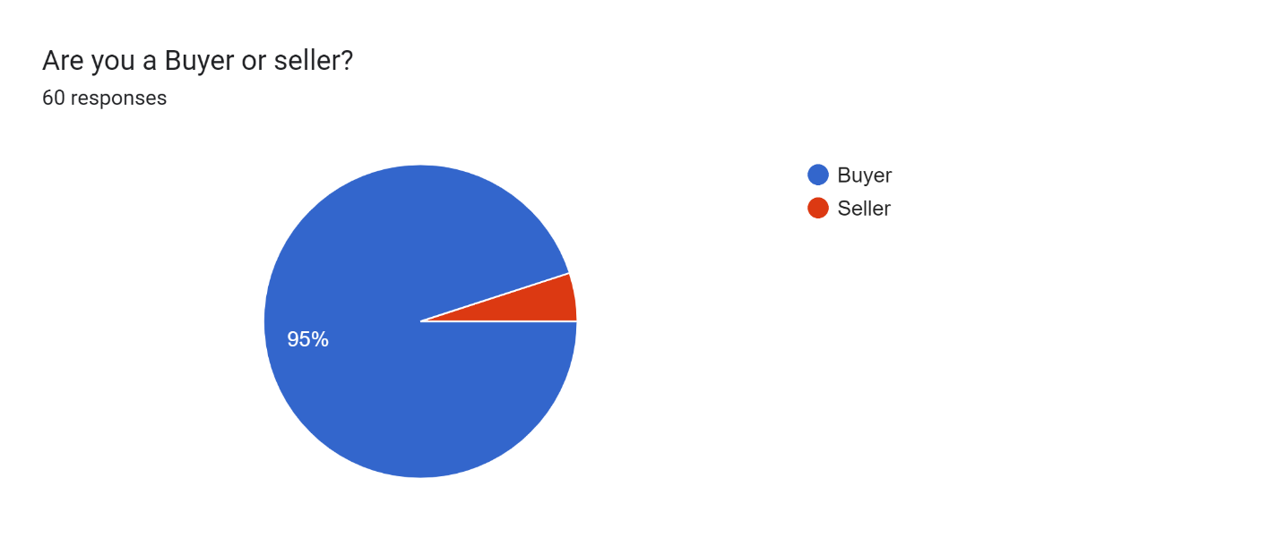

According to the pie chart above SLIIT students are using Online Shopping as Buyers as well as Sellers. Among them 95% of students are using Online Shopping as a Buyer!

## Products at top.

Nowadays people are more inclined towards online shopping due to rapid growth of technology. As a result of competition between learning processes in today ‘s world, most of the university students are interested in this online shopping.

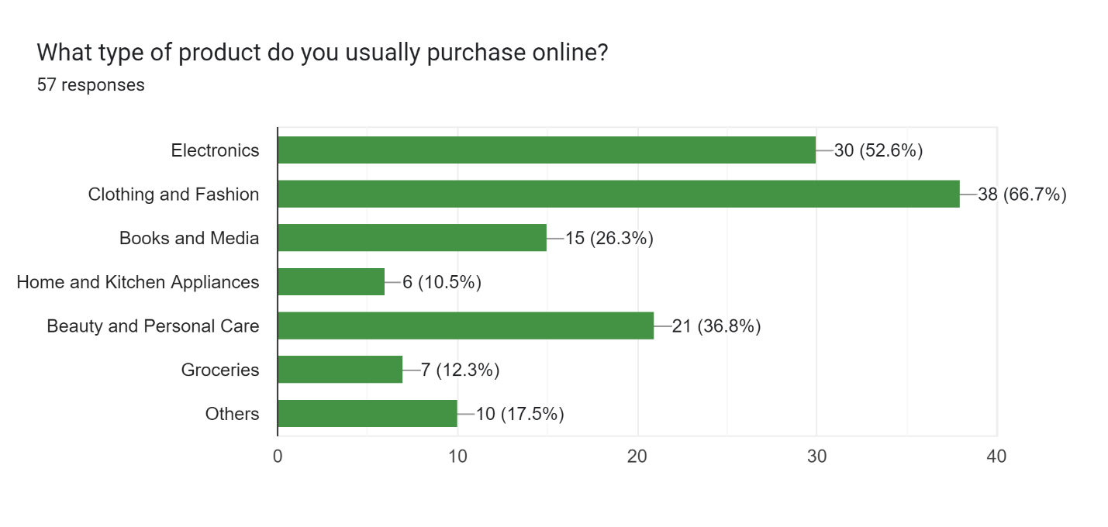

The above bar chart shows some of the products that students prefer to buy through online shopping. Those products are **Electronics, Clothing and fashion, Books and media, home and kitchen appliances, Beauty and personal care, groceries and other items**.

According to the bar chart, most of the students prefer to buy clothing and fashion through online shopping and it is about 66.7%. The least number of students prefer to buy home and kitchen appliances through online shopping. It is about 10.5%. About 52.6% of students prefer to buy books and media through online shopping. The percentage of students who wish to buy beauty and personal care is higher than the percentage of students who want to buy books and media. Accordingly, those percentages can be identified as 26.3% and 36.8% respectively. The difference between buying groceries and home and kitchen appliances through online shopping is a small percentage of 1.8%. As shown in the above bar chart, about 17.5% of students are willing to buy other products using online shopping in addition to the products mentioned above.

Forms response chart. Question title: How often do you shop online for goods or services?
. Number of responses: 55 responses.

According to the above pie chart, about 38.2% of SLIIT students often use online shopping methods to buy goods and services. About 34.5% of students buy goods and services through online shopping occasionally. According to this pie chart, about 14.5% of students rarely purchase goods and services through online shopping and about 10.9% of students buy products very often through online shopping. As well as the very small number of students, about 1.8%, do not use online shopping to purchase goods or services.

## Online Buying Platforms.

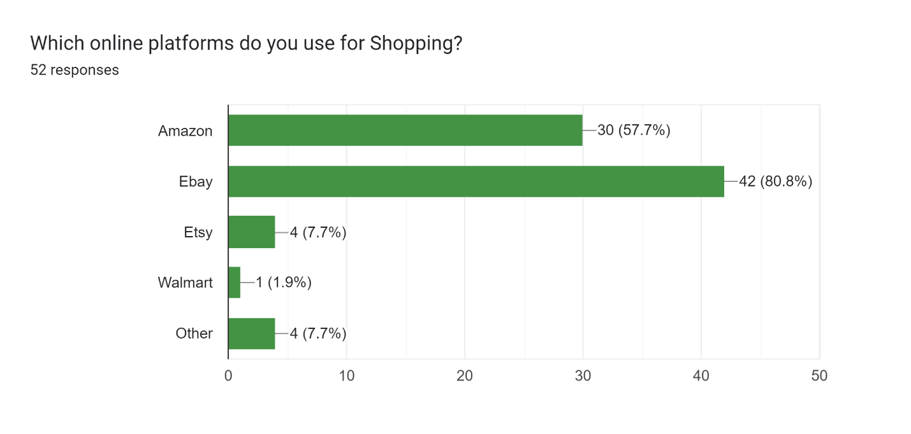

The above bar graph shows the online platforms used by students for online shopping. **Amazon, eBay, Etsy, Walmart** can be pointed out as the existing online platforms in this chart. As shown in the graph, most of the students prefer to use eBay for online shopping. It is a percentage of about 80.8%. The very least number of students with a percentage of 1.9% prefer online platform Walmart. According to this bar graph, more students prefer to use Amazon for online shopping than Etsy online platform. It is about 7.7% and 57.7% respectively. Apart from the online platforms shown in this bar chart, there are students who prefer to use other online platforms. It is a percentage of about 7.7%.

## Factors affect online Buying.

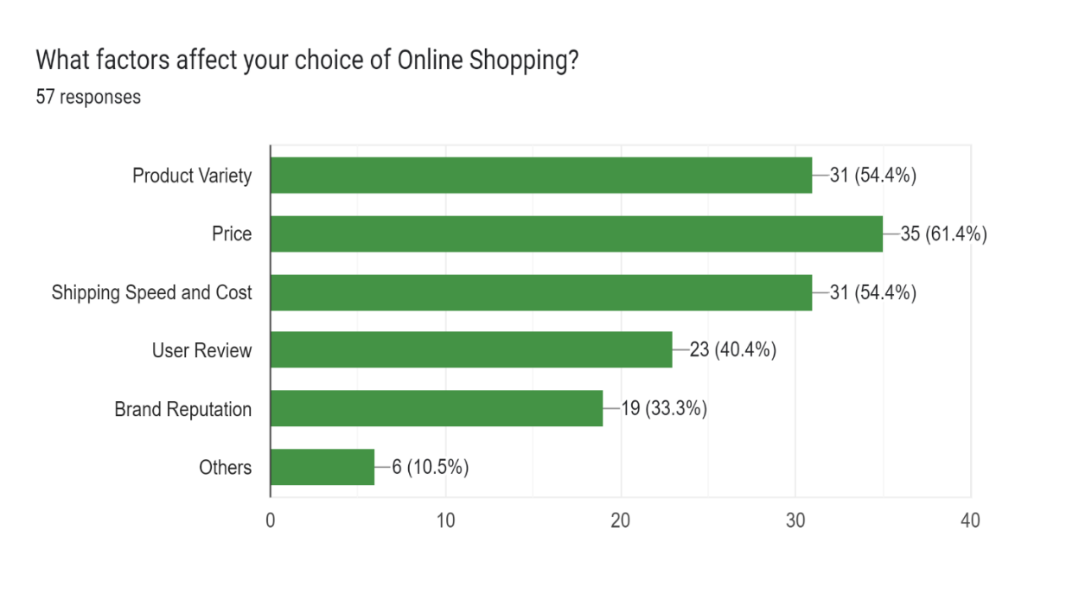

The above bar chart shows information about the factors that affect buyers of online shopping. The most affected factor was the product price, it was 61.4%. Product variety and shipping speed and cost were the same percentage according to the above bar chart, and it was 54.4%. The factor of user review was 40.4%. The factor that affected the least was brand Reputation, it represented 33.3%. 10.5% of buyers were affected by other factors.

## Methods of Payment.

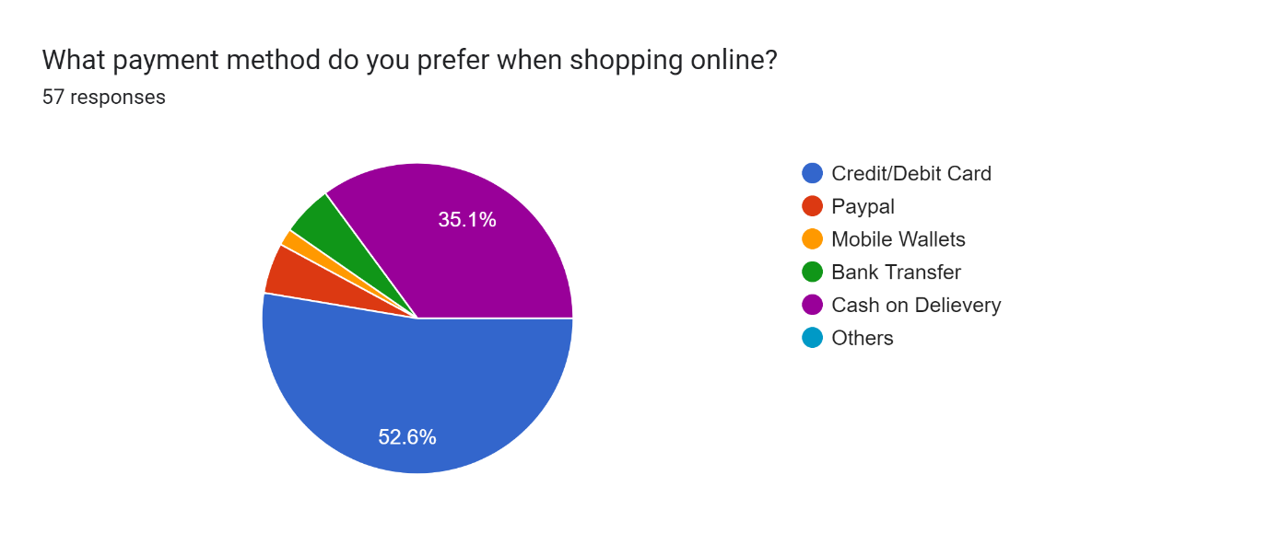

The following pie chart represents about payment methods which buyers prefer when shopping online. Many buyers used credit/debit cards and it was more than a half (52.6%). A significant number of buyers use cash on delivery when shopping and it was 35.1%. An equivalent percentage of buyers use PayPal and bank transfer was 5.3%. 1.8% of buyers use mobile wallets to pay their fee.

## Challenges as a Buyer.

Forms response chart. Question title: Have you faced any challenges as a seller?
. Number of responses: 21 responses.

The above pie chart compares the challenges they faced as a seller. According to the pie chart 33.3% of sellers have payment delay problems. As well as 33.3% of sellers did not face any challenges.28.6% of sellers have currency conversion issues as their challenge. The least number of sellers faced fraud or chargebacks and that was 4.8%.

**Personal Security**

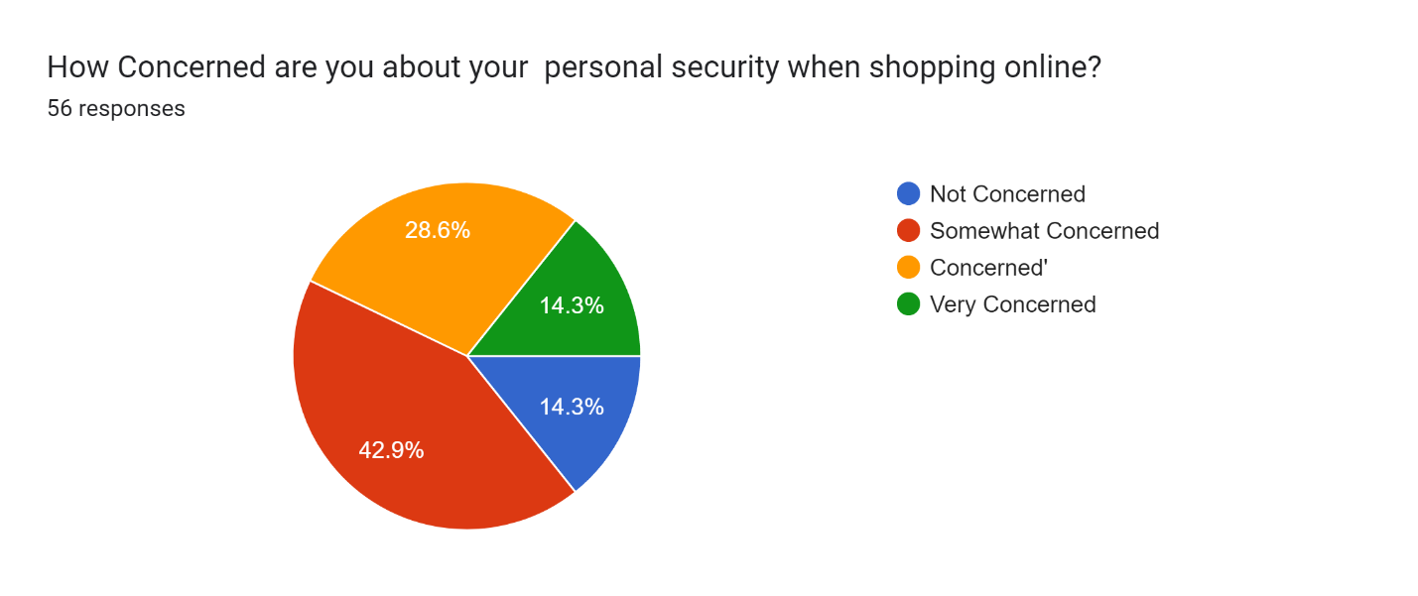

The pie chart represents information about personal security of buyers when shopping online. Many buyers somewhat concerned about personal security, 42.9%. An equivalent percentage of buyers were not concerned and very concerned, that was 14.3%. 28.6% of buyers were concerned about their personal security.

**Satisfaction over online shopping**

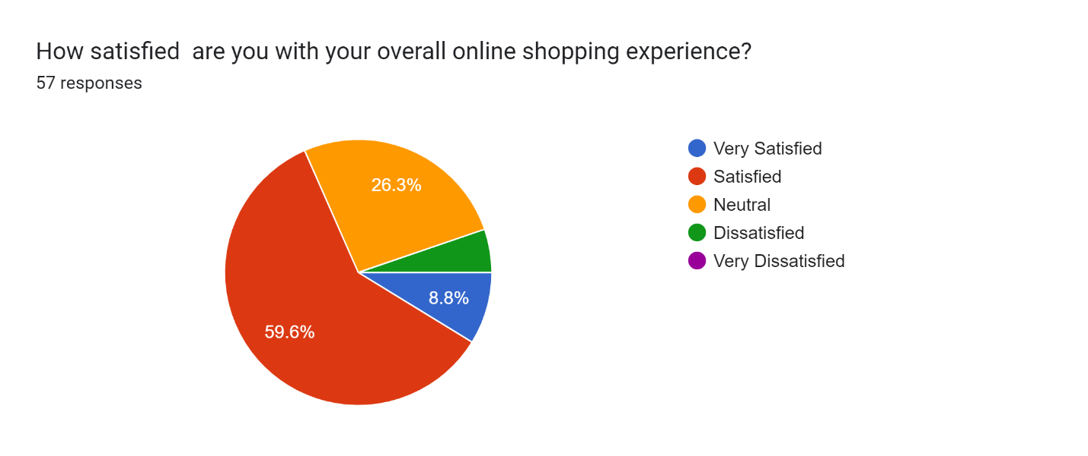

According to above pie chart, Most of the students are satisfied with the online shopping experience and it is about 59.6%.The least amount of students are dissatisfied with the online shoppimg experience. As shown in the graph, 26.3% of students are neutral and the 8.8% of students are very satisfied with online shopping experience.

**Suggestion in improvements on facilities**

In online shopping, facilities should be provided appropriately to suit different situations and time frames and they should be improved. Some of those improvements can be mentioned below.

1.Upgrading Technology.

2.Enhancing Amenities.

3.Increasing Accessibility.

4.Improving Energy Efficiency.

5.Upgrading Security Measures.

6.Creating Collaborative Spaces.

7.Enhancing Health and Safety.

8.Improving Maintenance Processes.

# Online Shopping with Sellers!

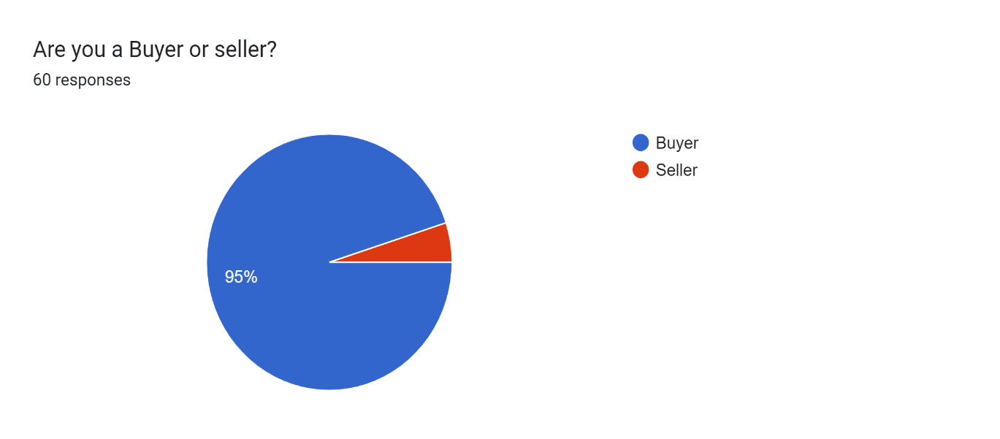

According to the pie chart above SLIIT students are using Online Shopping as Buyers as well as Sellers. Among them 5% of students are using Online Shopping as a Seller!

**Forms response chart. Question title: How would you describe the size of your online selling business?
. Number of responses: 3 responses.**

With the current economic situation in the country,the university has focused on various job opportunities for students,so online shopping can be shown as one of them which have been focused on.The following pie chart shows the students of SLIIT and How successfull they are with their online shopping business. According to this pie chart, about 66.7% of students are engaged in online shopping business in medium scale and 33.3% of students are engaged in small scale online shopping business. No one is engaged in large scale online businesses.

## Product of selling

Forms response chart. Question title: What type of product do you usually sell online?
. Number of responses: 3 responses.

The following bar graph shows the variety of products sold by students. These products include **Electronics, Clothing and Fashion, Books and Media, Home and Kitchen Appliances, Beauty and Personal Care, Groceries, and other items**. According to the survey, the percentage of students selling Electronics, Home and Kitchen Appliances, Beauty and Personal Care, and Groceries is 66.7%. Only 33.3% of the students prefer to sell Clothing and Fashion. There are no students who prefer to sell Books and Media.

## Online Selling Platforms.

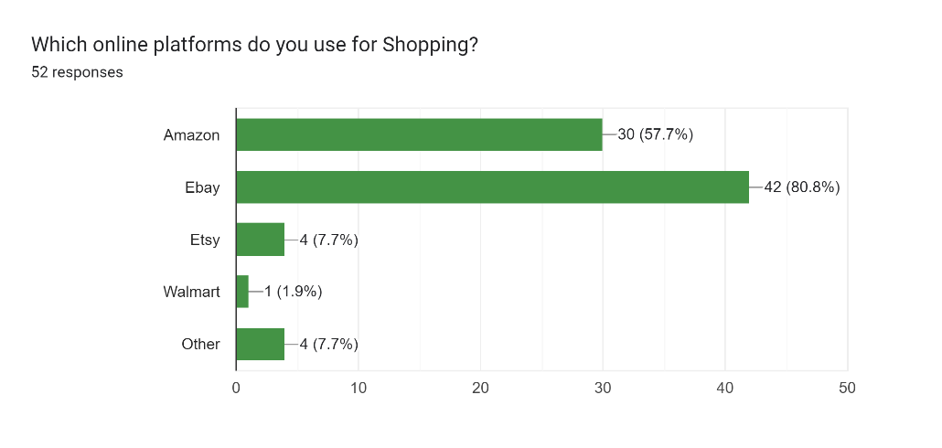

This bar graph illustrates the popularity of shopping platforms as a percentage. In today’s digital landscape, choosing the right online platform for selling your products or services is crucial.

There are so many online platforms for online marketing. Such as, **Amazon, eBay, Etsy, Walmart, Daraz, shopify.** According to this diagram, most of the people prefer to deal through eBay, it is 42% as a percentage. Second most people prefer to do deal trough amazon.it is 30.0% as a percentage. Least popular platform is a Walmart.it is 1% as a percentage. Other platform have 10% less preference. The choice of platform can significantly impact your reach and sales potential.

## Strategies of attracting customers

Forms response chart. Question title: What strategies do you use to attract customers in online marketplace?
. Number of responses: 3 responses.

The above bar chart depicts the use of strategies to attract customers in the online marketplace. Sell high quality products and sell unique products are the most used strategies by sellers. It is 66.7% as a percentage. The other three strategies have similar percentages. It is 33.3% as percentage.

## Challenges as a seller

Forms response chart. Question title: Have you faced any challenges as a seller?
. Number of responses: 21 responses.

The above pie chart shows the challenges faced as a seller. There are four main challenges. Payment delays, currency conversion issues, fraud or chargebacks, fraud or chargebacks according to the given pie chart the biggest challenge is payment delay while the least percentage of sellers faced fraud or chargebacks. As a percentage payment delay is 33.3%. As a pie chart significant thing is 33.3% percentage of sellers also has not faced any challengers.

## Handling online selling Business

Forms response chart. Question title: How do you handle customer inquiries, feedback, and potential returns?
. Number of responses: 3 responses.

The bar chart depicts four key customer service policies. Having a clear return/refund policy and responding to inquiries within 24 hours both receive a high approval rating of 66.7%. However, providing replacements for defective products shows a concerning 0% approval rate. Welcoming and valuing customer feedback is acknowledged by 33.3% of respondents, indicating a moderate level of satisfaction. In summary, the chart underscores the need to address the deficiency in defective product replacements while maintaining strong policies in refund clarity and quick inquiry response.

As sellers everyone should have proper **Shipping and Delivery Management.** Let’s clarify some information.

Forms response chart. Question title: How do you handle customer inquiries, feedback, and potential returns?
. Number of responses: 3 responses.

According to the above bar chart 66.7% of sellers have a clear return or refund policy. As well as 66.7% of sellers respond within 24 hours to the inquiries. 33.3% of sellers Welcome and value customer feedback. The percentage of providing replacements for detective products is 0.0%. The percentage of sellers who have a clear refund and return policy and sellers who respond within 24 hours to inquiries is the same.

As sellers we should **offer special promotions and discounts to the customers!**

Forms response chart. Question title: Do you offer any special promotions or discounts to your customers?
. Number of responses: 3 responses.

According to the above pie chart students of SLIIT who use online shopping as sellers have different aspects about giving special promotions and discounts for the customers. Most number of students regularly offer special promotions and discounts to the customers, and it is 66.7%. As well as that 33.3% of students offer discounts and promotions occasionally. There is no one who prefers to maintain consistent pricing.

# Conclusion

Based on the survey results, online shopping is a popular activity among SLIIT students. Convenience and wide product selection are the primary motivations, while concerns about security and privacy persist. These findings suggest the need for:

Recommendations:

* The university should organize workshops or seminars to educate students about online security and privacy measures.
* Encourage the use of secure digital payment methods and provide information on safe online transactions.
* Collaborate with e-commerce platforms to ensure product quality and return policies to alleviate concerns about not physically inspecting items.
* Support and promote local e-commerce platforms to boost the local economy and provide students with more choices.
* Enhance the efficiency of home delivery services, making them even more convenient for students.

By implementing these recommendations, SLIIT can better support students in their online shopping endeavors while addressing their concerns, ultimately contributing to a more informed and secure online shopping environment for the university community.

# References

* <https://courseweb.sliit.lk/course/view.php?id=2812>
* [**https://chat.openai.com/**](https://chat.openai.com/)
* [**https://www.youtube.com/**](https://www.youtube.com/)

# Appendices



